If an ethernet port on a router was assigned an IP address of 172.16.112.1/20, what is the maximum number of hosts allowed on this subnet?

A – 1024  
B – 2046  
C – 4094  
D – 4096  
E – 8190

Refer to the exhibit. The internetwork is using subnets of the address 192.168.1.0 with a subnet mask of 255.255.255.224. The routing protocol in use is RIP version 2. Which address could be assigned to the FastEthernet interface on RouterA?

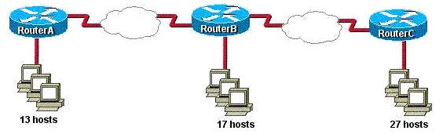

A – 192.168.1.31  
B – 192.168.1.64  
C – 192.168.1.127  
D – 192.168.1.190  
E – 192.168.1.192

Refer to the exhibit. HostA cannot ping HostB. Assuming routing is properly configured, what could be the cause of this problem?

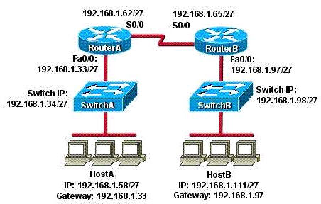

A – HostA is not on the same subnet as its default gateway.  
B – The address of SwitchA is a subnet address.  
C – The Fa0/0 interface on RouterA is on a subnet that can’t be used.  
D – The serial interfaces of the routers are not on the same subnet.  
E – The Fa0/0 interface on RouterB is using a broadcast address.

Given a subnet mask of 255.255.255.224, which of the following addresses can be assigned to network hosts? (Choose three)

A – 15.234.118.63  
B – 92.11.178.93  
C – 134.178.18.56  
D – 192.168.16.87  
E – 201.45.116.159  
F – 217.63.12.192

Which of the following host addresses are members of networks that can be routed across the public Internet? (Choose three)

A – 10.172.13.65  
B – 172.16.223.125  
C – 172.64.12.29  
D – 192.168.23.252  
E – 198.234.12.95  
F – 212.193.48.254

A national retail chain needs to design an IP addressing scheme to support a nationwide network. The company needs a minimum of 300 sub-networks and a maximum of 50 host addresses per subnet. Working with only one Class B address, which of the following subnet masks will support an appropriate addressing scheme? (Choose two)

A – 255.255.255.0  
B – 255.255.255.128  
C – 255.255.252.0  
D – 255.255.255.224  
E – 255.255.255.192  
F – 255.255.248.0

Refer to the diagram. All hosts have connectivity with one another. Which statements describe the addressing scheme that is in use in the network?

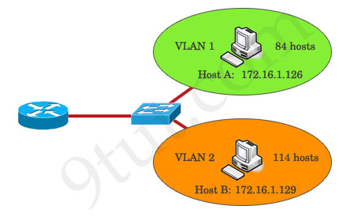

A – The subnet mask in use is 255.255.255.192.  
B – The subnet mask in use is 255.255.255.128.  
C – The IP address 172.16.1.25 can be assigned to hosts in VLAN1.  
D – The IP address 172.16.1.205 can be assigned to hosts in VLAN1.  
E – The LAN interface of the router is configured with one IP address.

Refer to the exhibit. Which VLSM mask will allow for the appropriate number of host addresses for Network A?

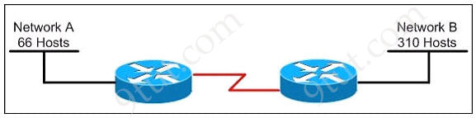

A. /25  
B. /26  
C. /27  
D. /28

Refer to the exhibit. Which subnet mask will place all hosts on Network B in the same subnet with the least amount of wasted addresses?



A. 255.255.255.0  
B. 255.255.254.0  
C. 255.255.252.0  
D. 255.255.248.0

On the network 131.1.123.0/27, what is the last IP address that can be assigned to a host?

A. 131.1.123.30  
B. 131.1.123.31  
C. 131.1.123.32  
D. 131.1.123.33